Name:

### Score: out of

# Manjimup SHS 2015

# Year 11 Mathematics Methods

# Test 1

# Trigonometry, Radian Measure & Functions

**20**

**Non Calculator Section (No calculator or notes, formula sheet provided)**

**Time: 20 minutes Marks: 20 marks**

**Question 1 [5 marks]**

Consider the two right triangles shown below.

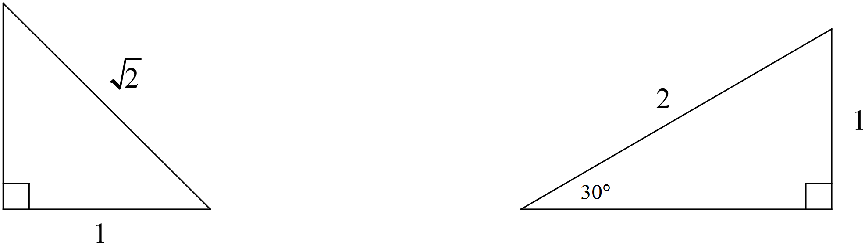

(a) Complete each triangle i.e. determine all the missing sides and angles. Write your answers on the diagrams above.

(1 mark)

(b) Use your triangles to help you determine the **exact** value of

(i) sin 150°

(ii) cos 225°

(iii) θ , where tan θ =  for −180° ≤ θ ≤ 180°

(4 marks)

**Question 2 [4 marks]**

Use the unit circle below to answer the questions that follow. Give your answers to an appropriate degree of accuracy.

 (a) Determine the value of sin 110°

(2 marks)

(b) Solve for x

cos x° = −0.7 for 0° ≤ x ≤ 360°

(2 marks)

**Question 3 [4 marks]**

The triangle shown below has an area of 36 cm2, determine the value of x.

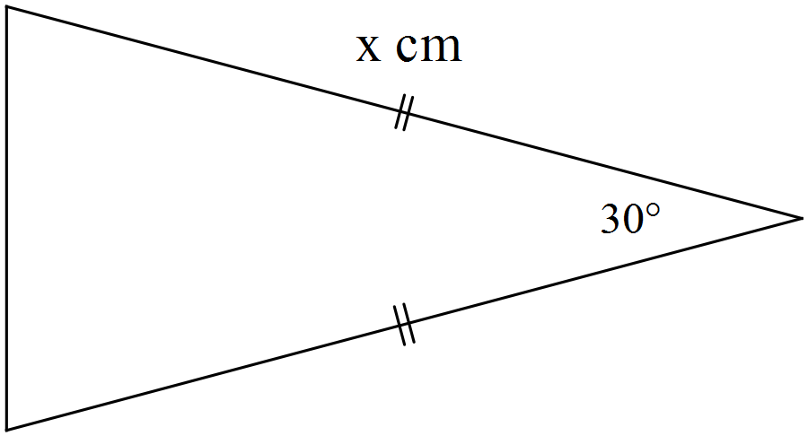

**Question 4 [7 marks]**

Given the functions f(x) = 2x − 3 h(x) = 

g(x) = x2 +2x – 8 j(x) = 4 − 

determine

(a) h(0)

(1 mark)

(b) g(−2)

(1 mark)

(c) f(2t – 1)

(1 mark)

(c) x such that f(x) = j(x)

(2 marks)

(d) the domain and range of h(x)

(2 marks)

Name:

### Score: out of

# Manjimup SHS 2015

# Year 11 Mathematics Methods

# Test 1

# Trigonometry, Radian Measure & Functions

**32**

**Calculator Section (Calculators and 1 page (A4) of notes permitted, formula sheet provided)**

**Time: 40 minutes Marks: 32 marks**

**Question 5 [2 marks]**

Determine the equation of the linear function shown below. All values should be expressed in exact form.

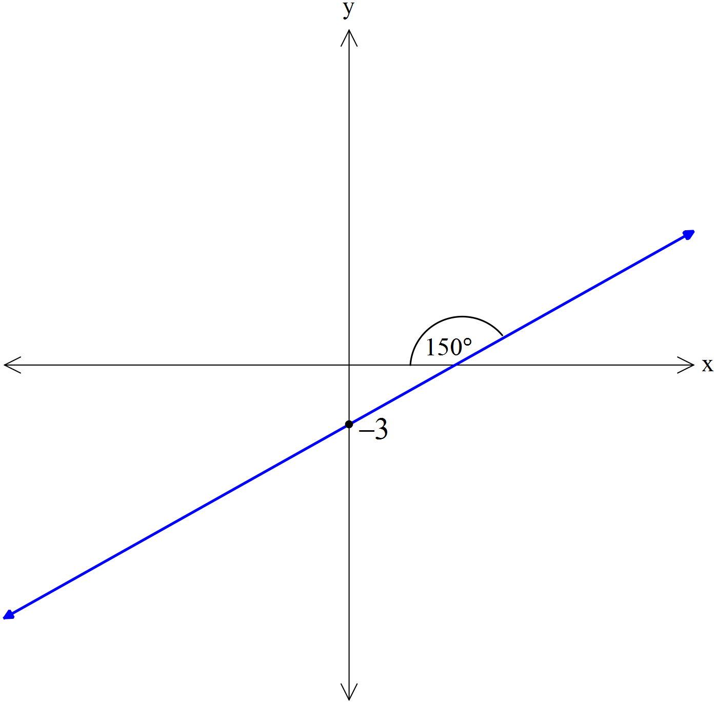

**Question 6 [5 marks]**

Indicate which of the following represent functions with the letter **F**. For those that are functions, state the natural domain and corresponding range.

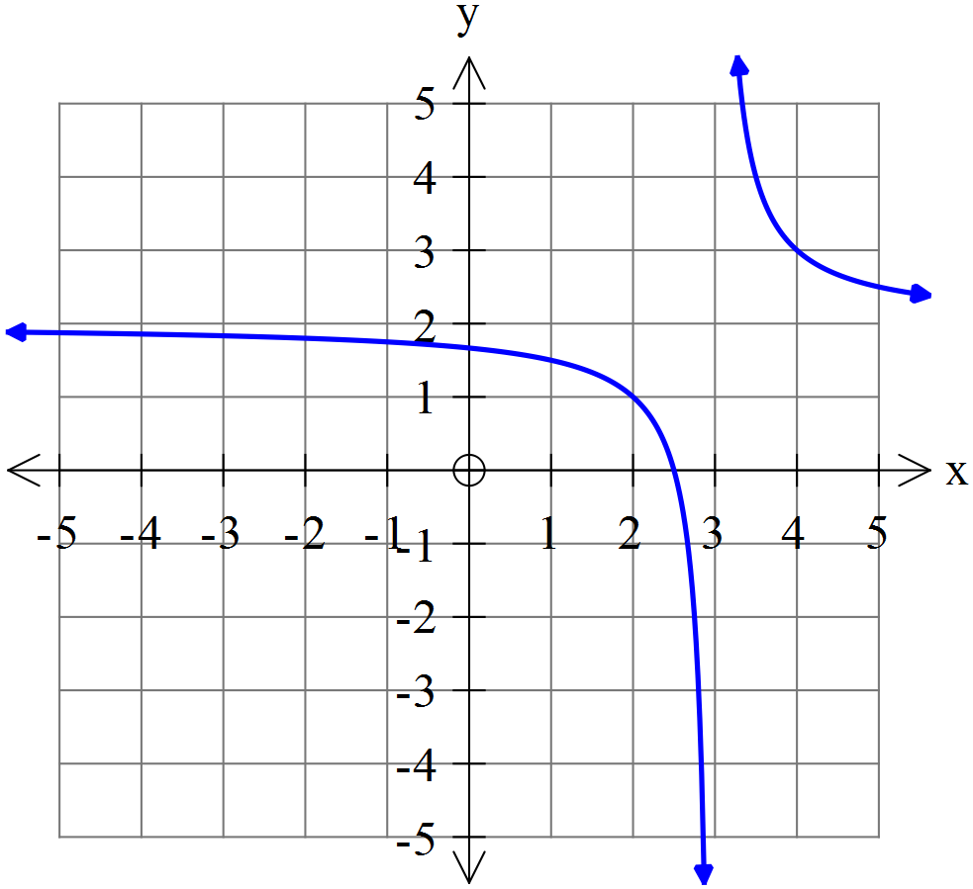 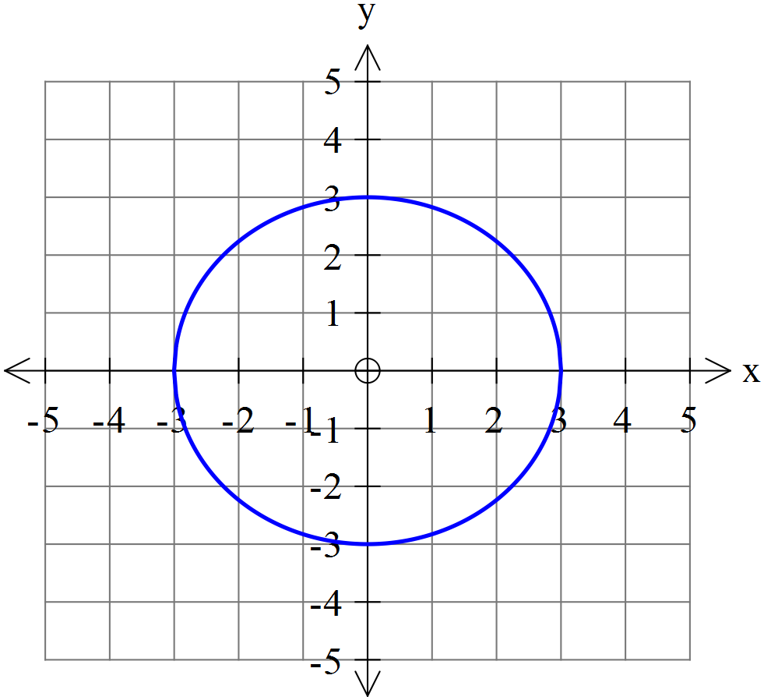 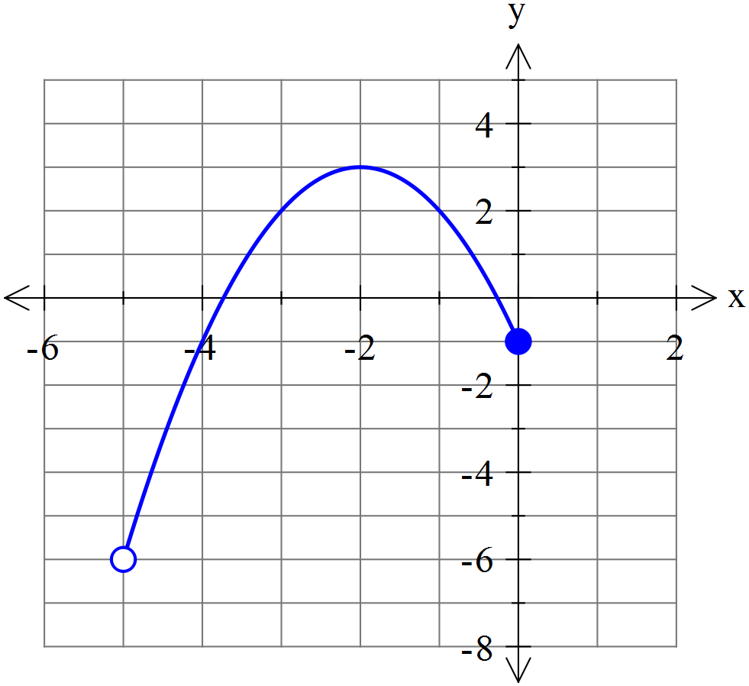

**Question 7 [8 marks]**

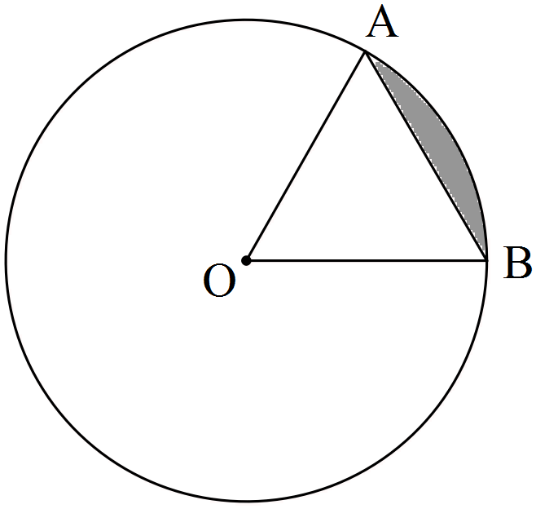

The circle shown with centre O has a radius of 3π cm.

If the size of ∠AOB = 60°, determine the

(a) area of triangle AOB as an **exact** value in terms of π.

(2 marks)

(b) length of the ***major*** arc AB accurate to 2 decimal places.

(2 marks)

(c) area of the ***minor*** sector AOB to the nearest cm2.

(2 marks)

(d) area of the ***minor*** segment (shaded) formed by the chord AB accurate to 3 significant figures.

(2 marks)

**Question 8 [5 marks]**

Triangle ABC drawn below has sides of 32 cm, 46 cm and 48 cm. The circle with a radius of 11 cm is inscribed inside the circle and just touches the three sides of the triangle.

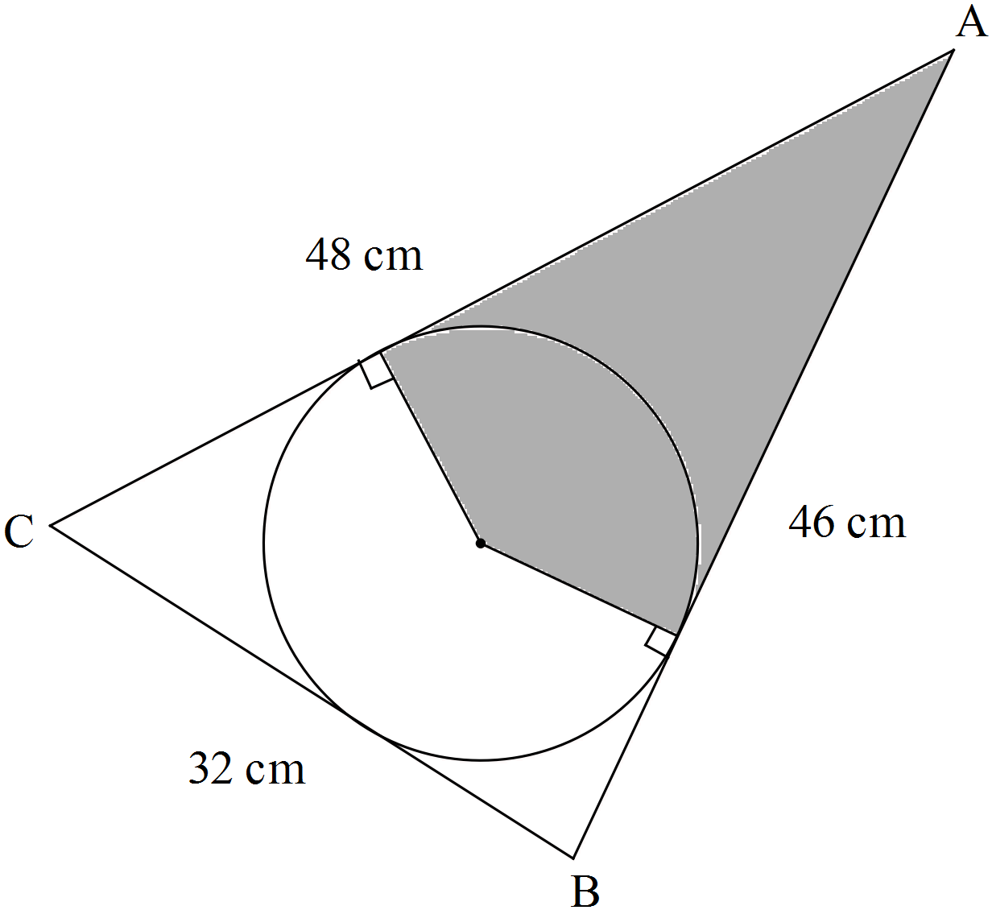

Note: Diagram not drawn to scale.

Determine the area of the shaded region. (Hint: First find the size of ∠BAC).

**Question 9 [6 marks]**

Determine, correct to 2 decimal places, the length of side BD in the diagram below.

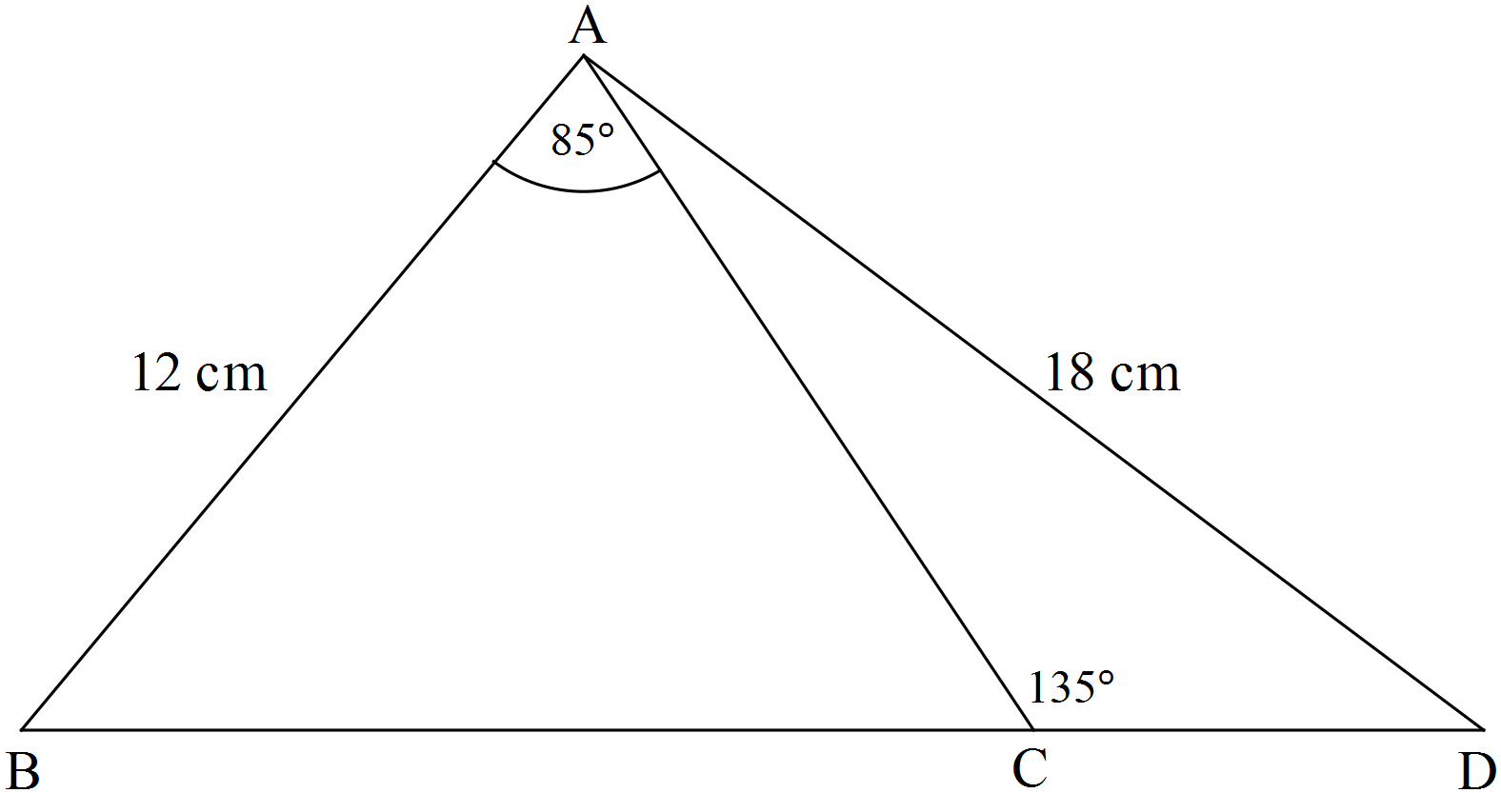

Note: Diagram not drawn to scale.

**Question 10 [6 marks]**

A radio mast is supported by two wires MP and MQ each attached to point M which is 12 metres from the base B of the mast. B, Q and P are all on level ground with Q due East of the mast and P due South of the mast.

If MP = 15 metres and MQ = 18 metres, determine the angle between the wires i.e. find ∠QMP.

